# FUNCTIONAL GUIDE FOR PROJECT MANAGER APPLICATION

## 1. Default landing page on launching the host URL: View Task page

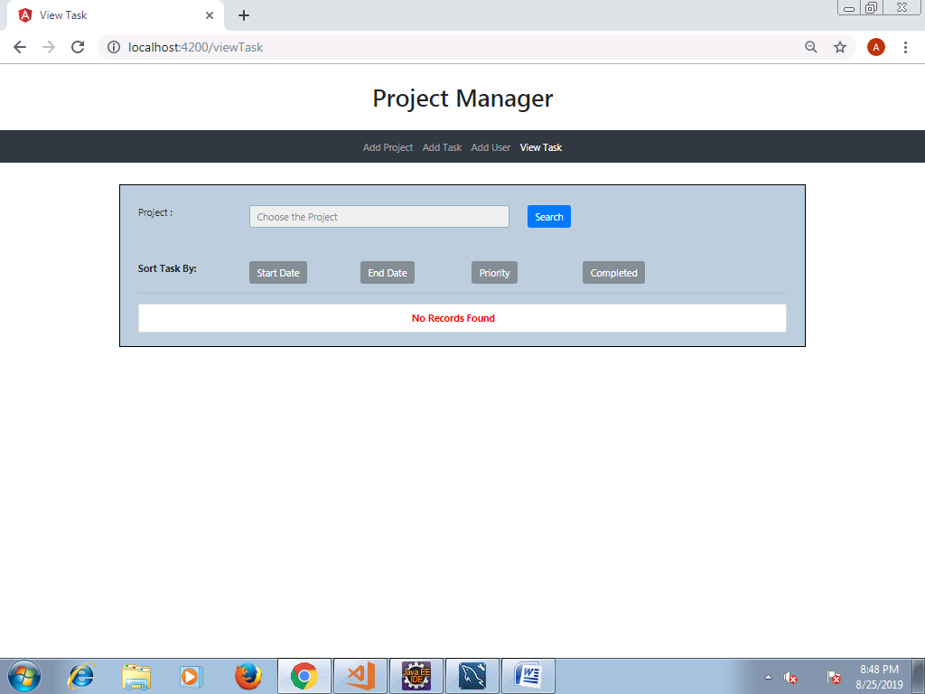

## 2. Adding User Details

* Home screen of Add User Page

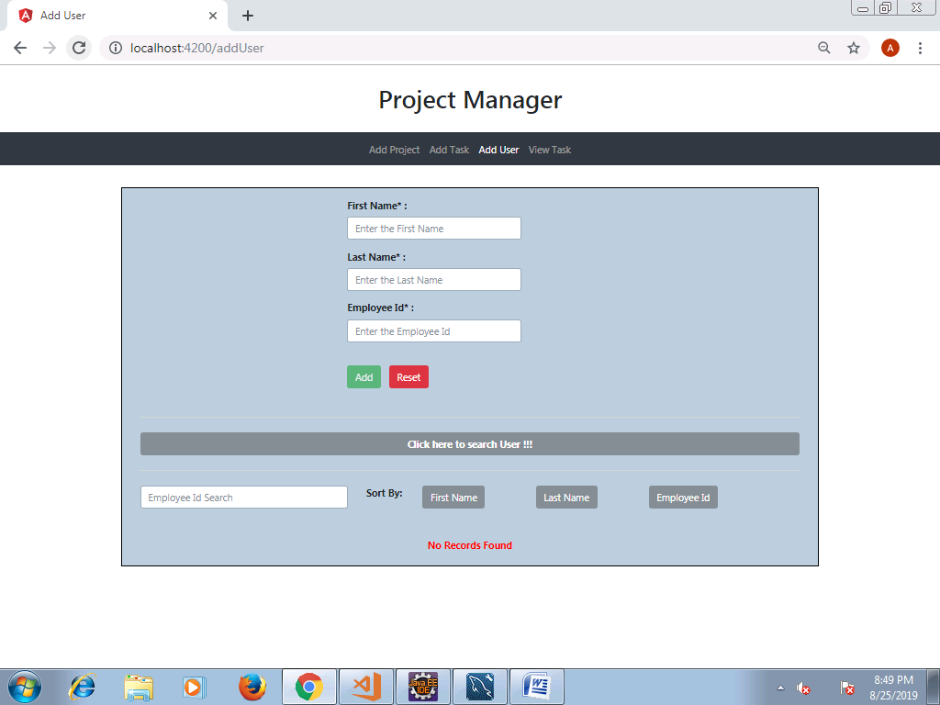

* User can enter First Name, Last Name and Employee ID (all are mandatory). If field validations are passed, a message pops up saying successful registration as seen below and the User details get added.

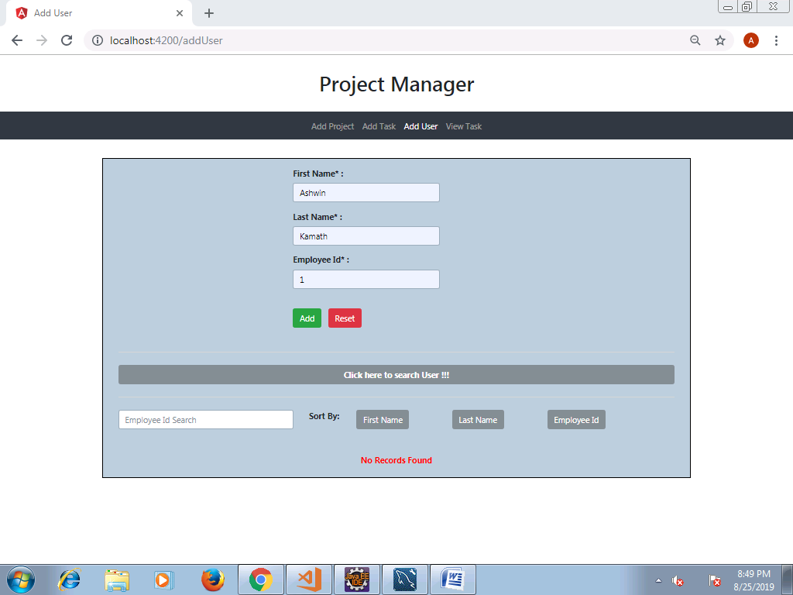

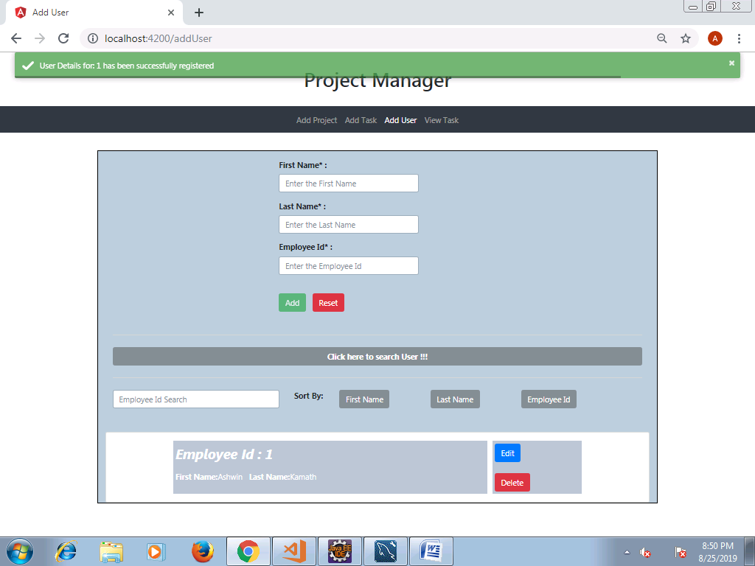

* Appropriate basic field validations are handled as below for each field.

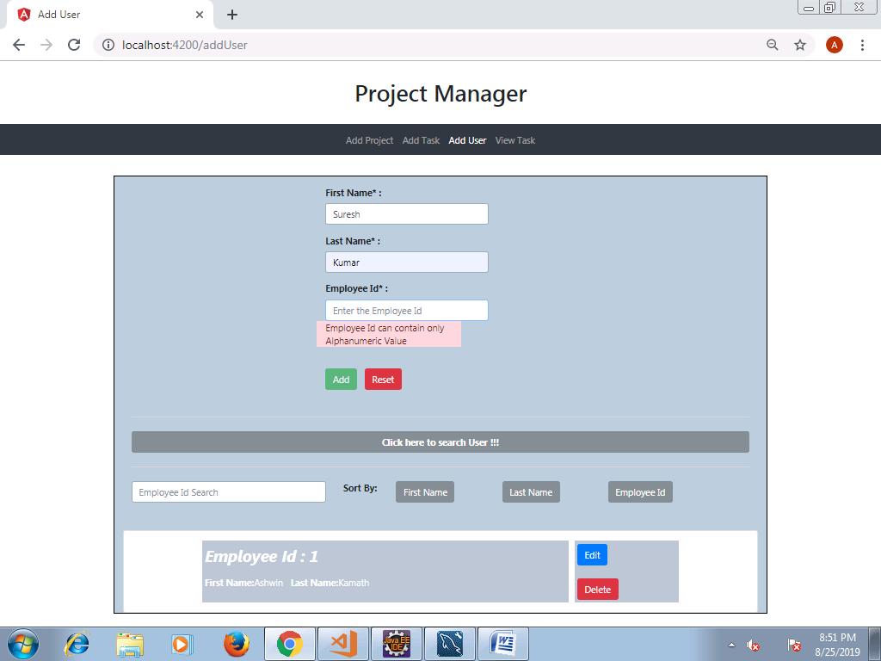

* As and when new users are added, the data gets added in the bottom of the page.



* The user can click on ‘Search User’ button to search the user available in the user list based on First Name, Last Name or Employee ID.

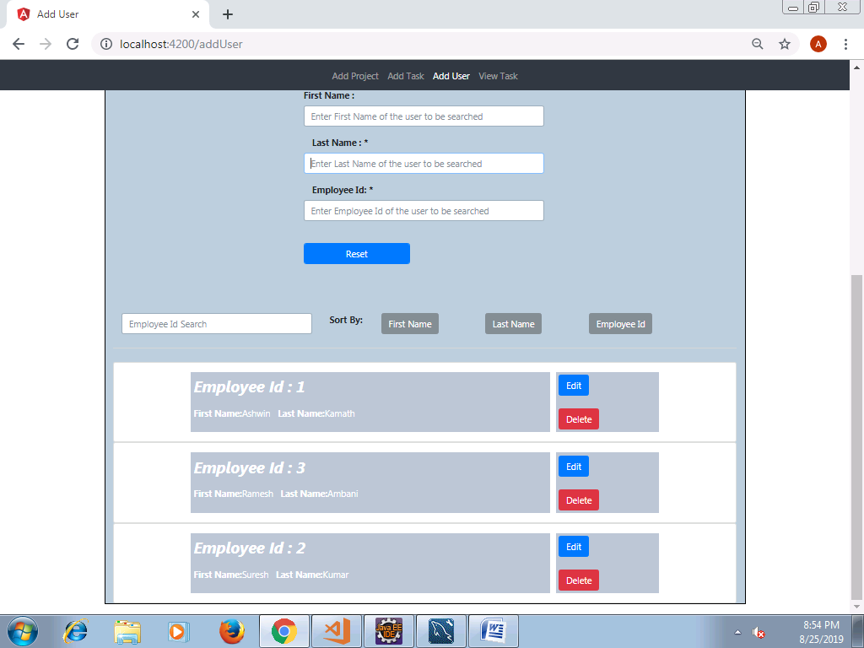

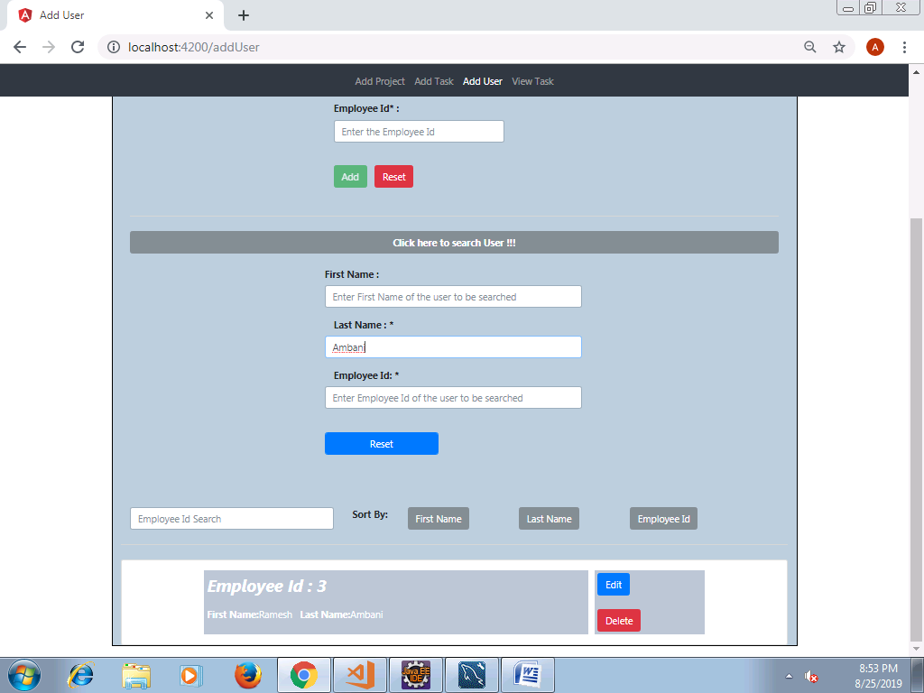

* The user can sort the records based on the first name, last name and employee ID. Below are examples for same in the given order.

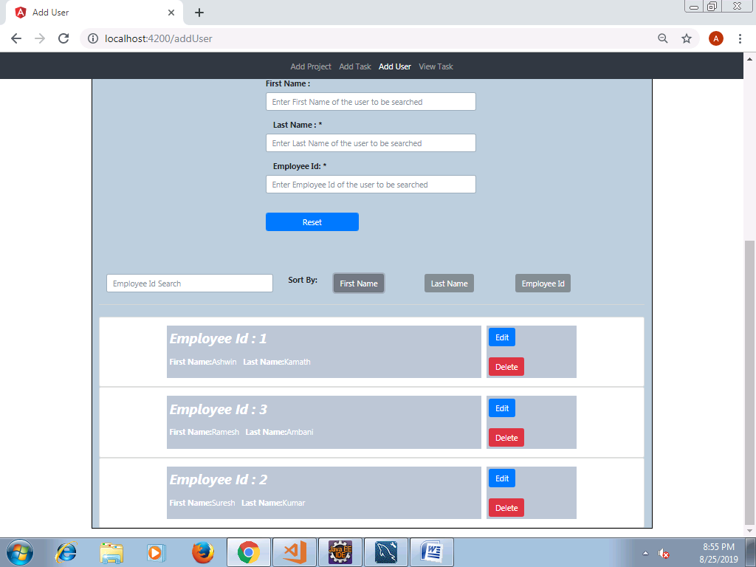

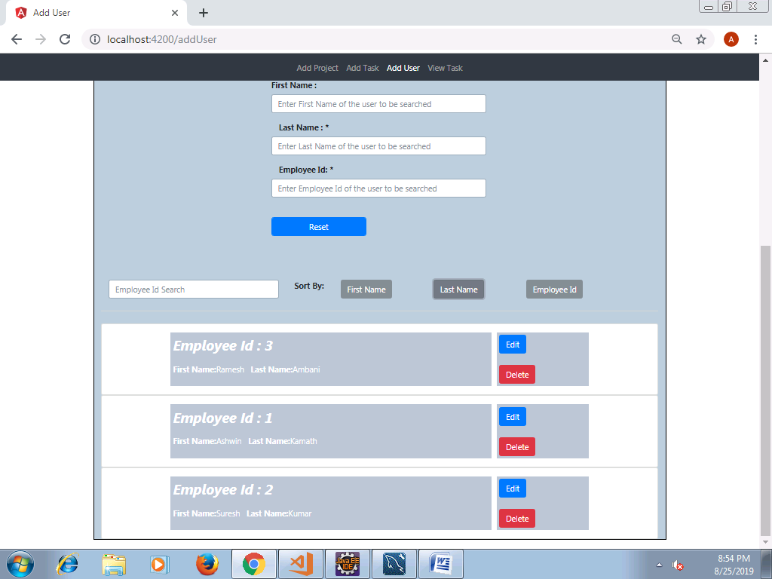

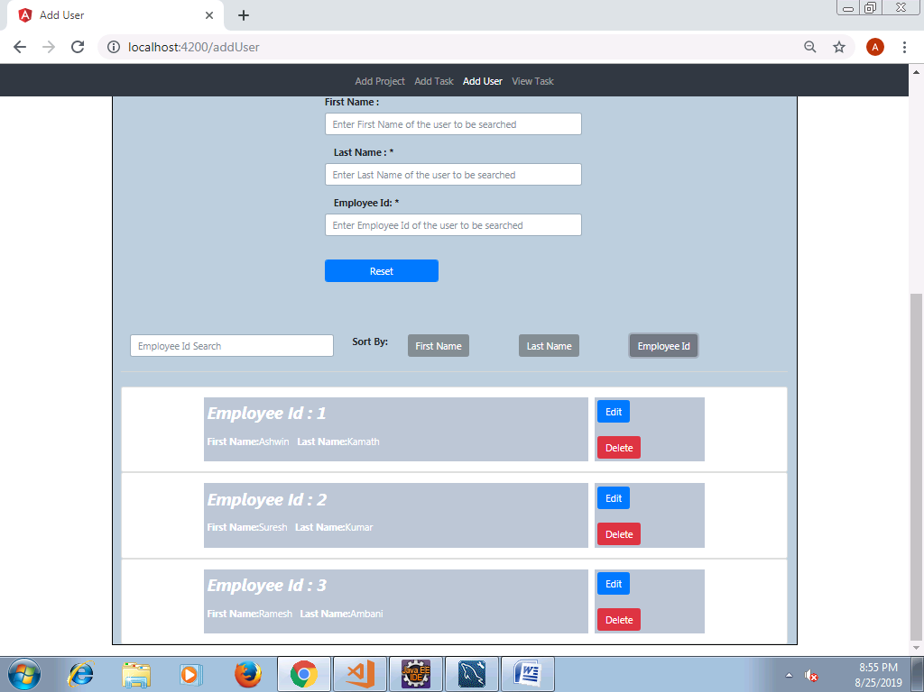

* User details can be edited. On clicking Edit, the user info can be edited. Once edited, click on Update; On successful update, a popup shows up saying the update is successful.

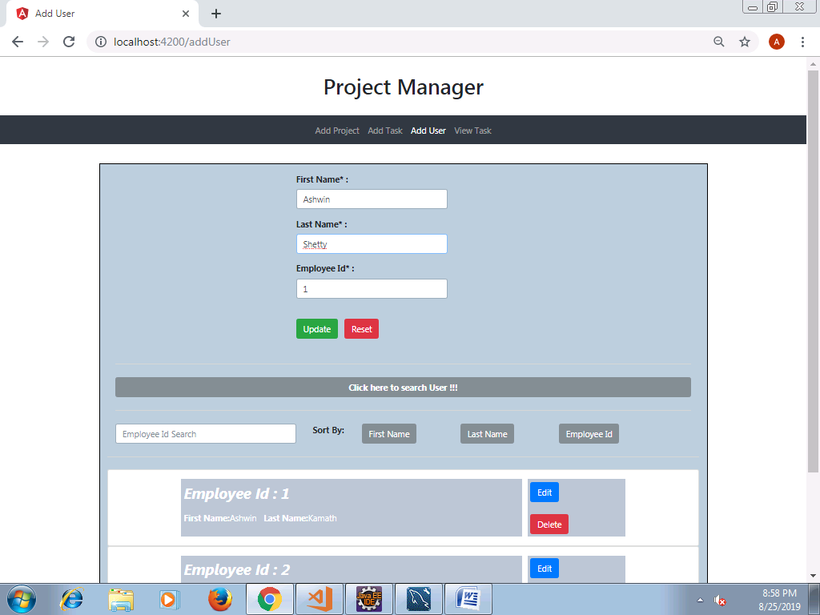

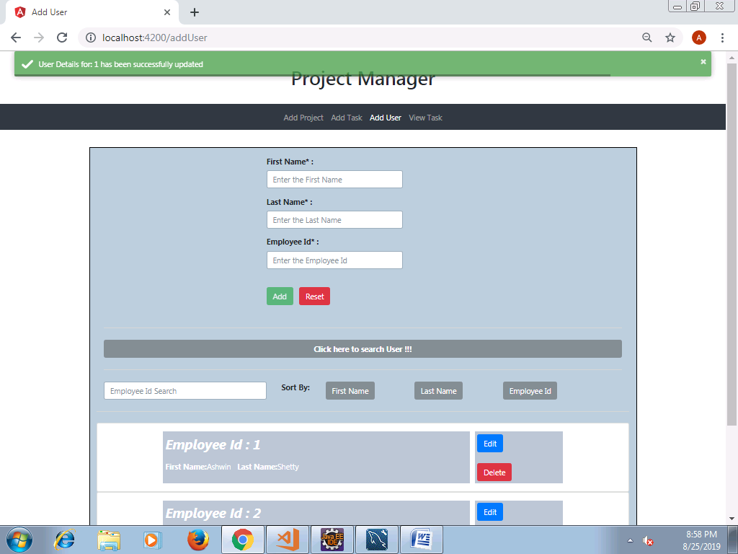

* User details can be deleted. On clicking delete, the user gets deleted if he is not associated with any Task or Project. Below is the screenshot for same.
* User is not associated with any Task/Project; hence the User gets deleted.

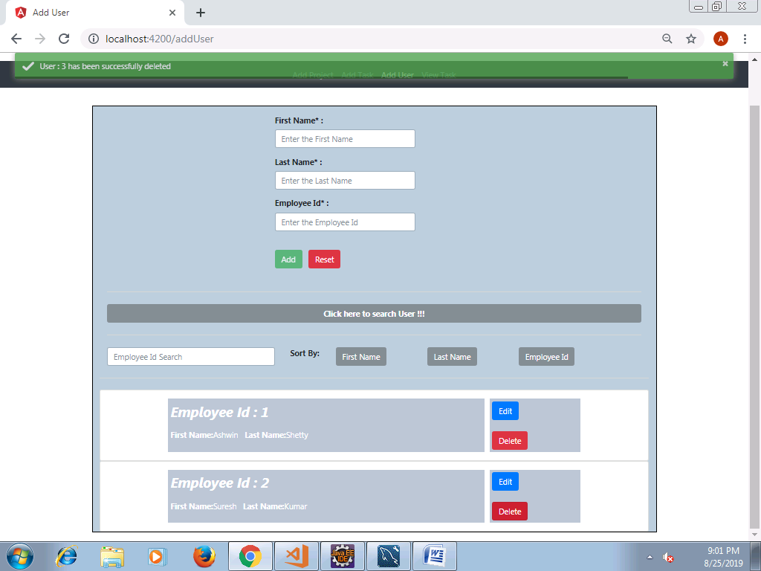

* User is associated with of the Task/Project; hence the User doesn’t get deleted.

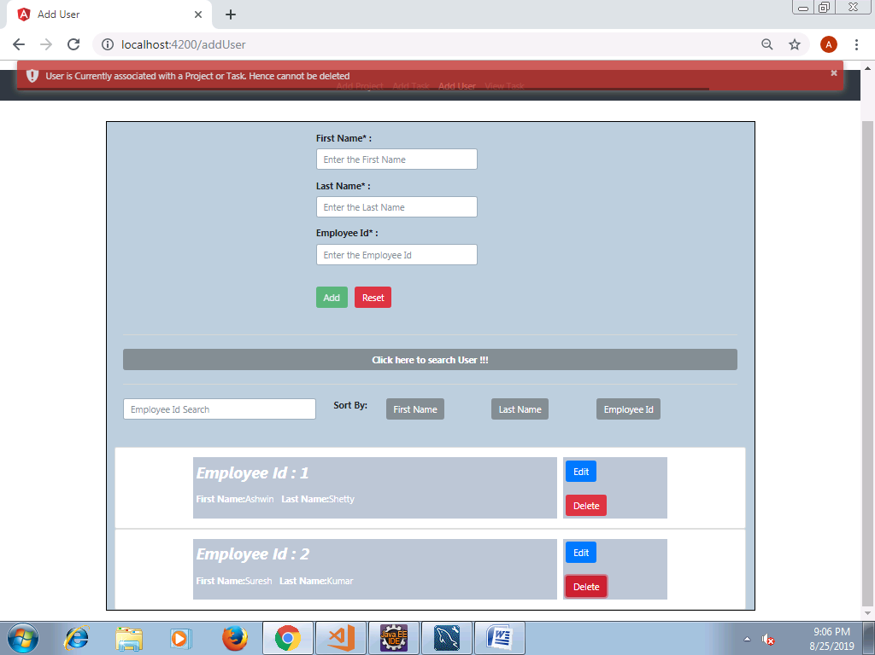

## 3. Adding Project Details

* User can enter the project details like Project Name, Start End Date and Priority.

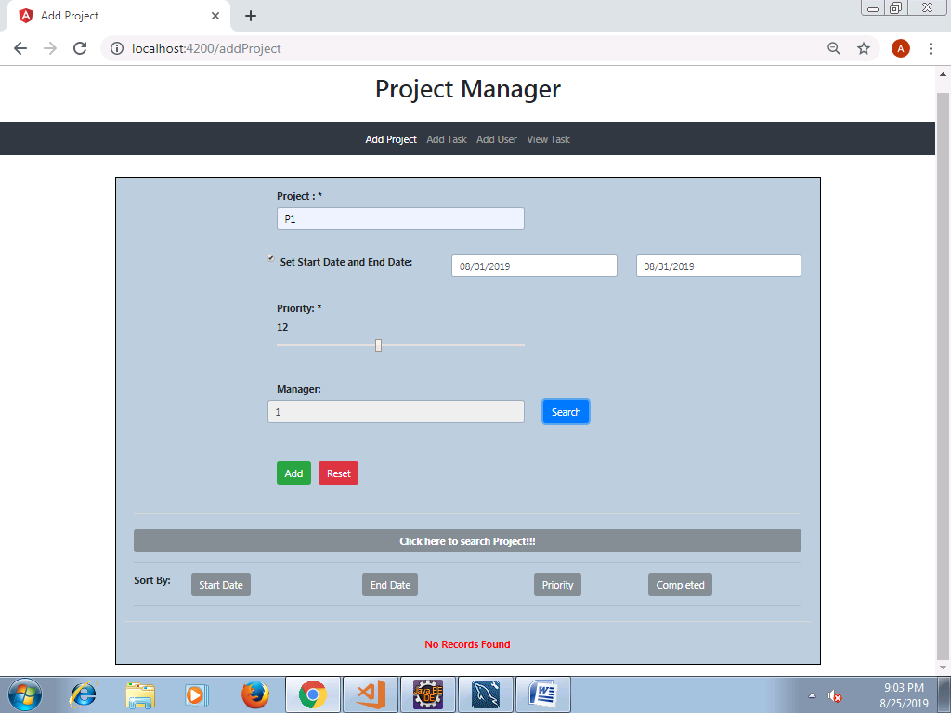

* On clicking on Search button across Manger option, the user can search the manager from user list by clicking on Search.

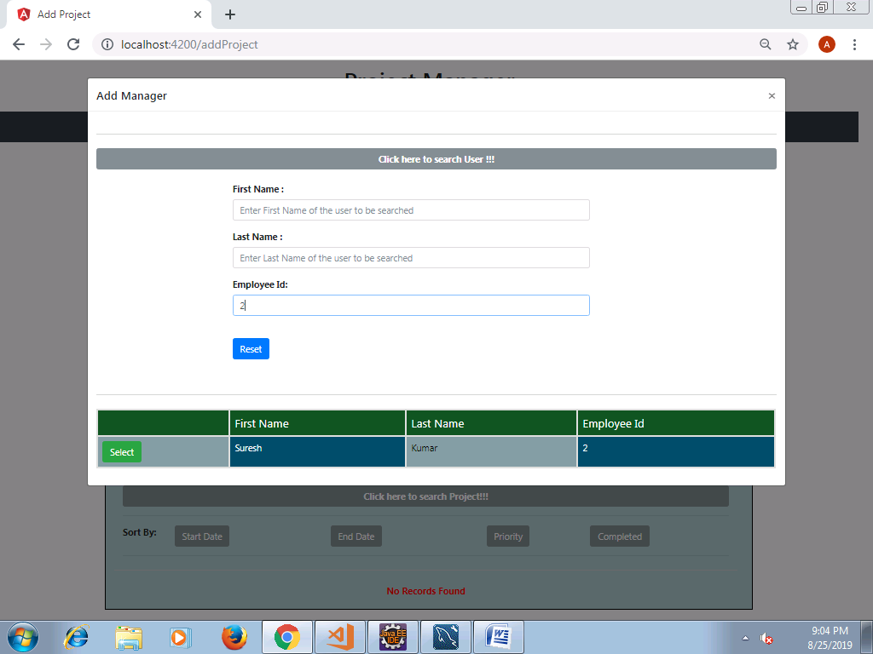

* Click on "Search User" to specifically search from the list of users and click on Select to add the user as manager.

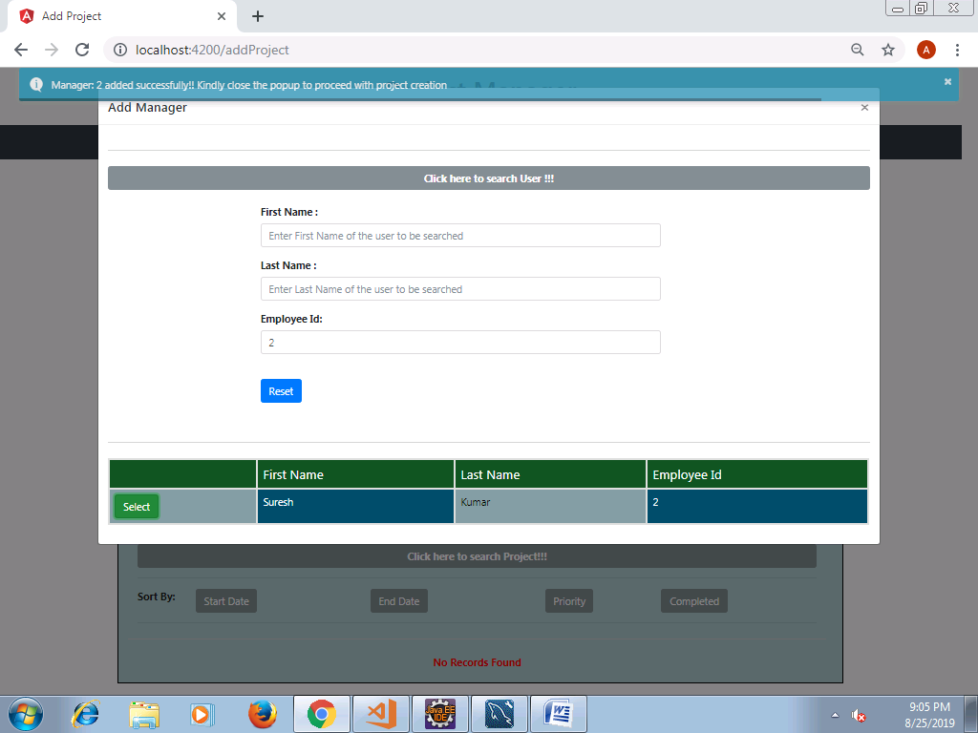

* The user can click on reset to cancel the specific search. All the list of users will be displayed.
* Similar to adding Users, the Projects can be sorted based on the Start Date, End Date, Priority, Completed. Below is an example for sort based on Priority.

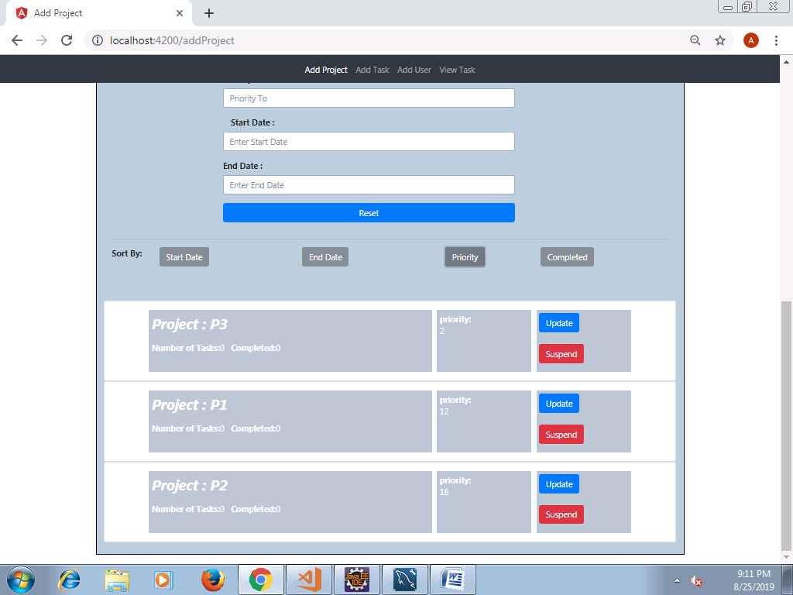

* Project details can be edited. On clicking Edit, the project info can be edited. Once edited, click on Update; On successful update, a popup shows up saying the update is successful.

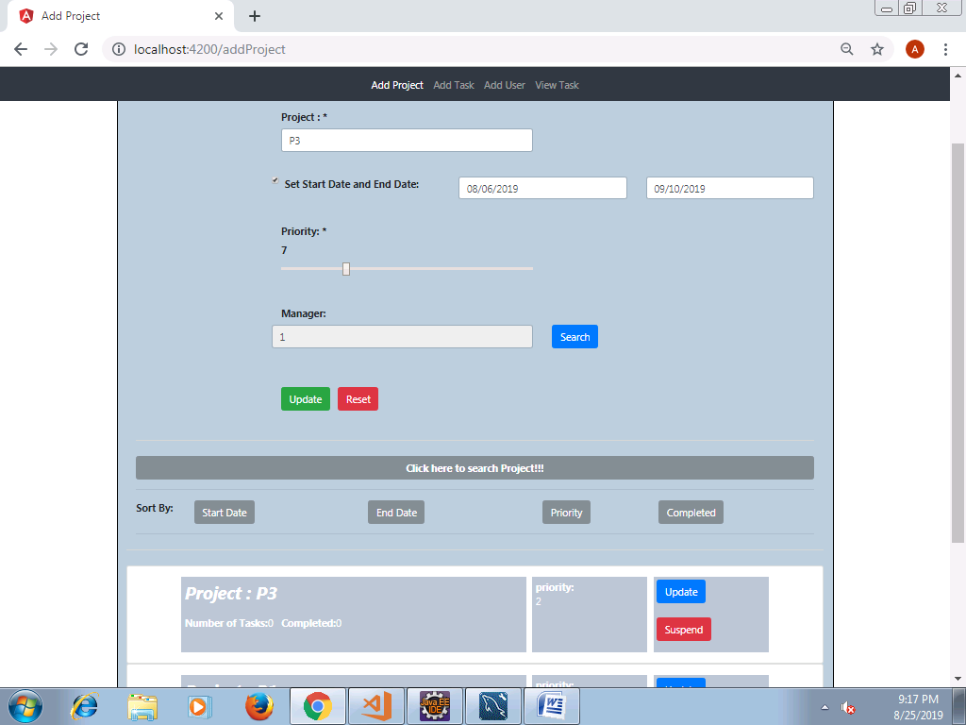

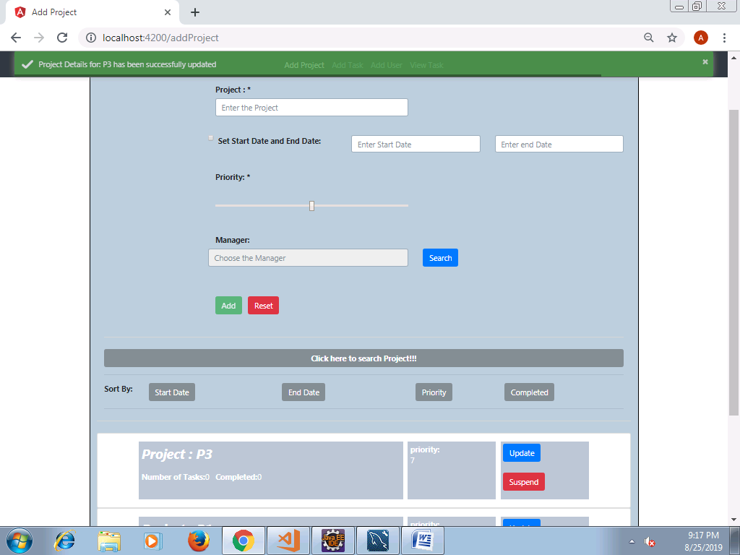

* The user can suspend the project or Update the project info if it is not associate to any task.
* Project cannot be suspended as its associated with a task.

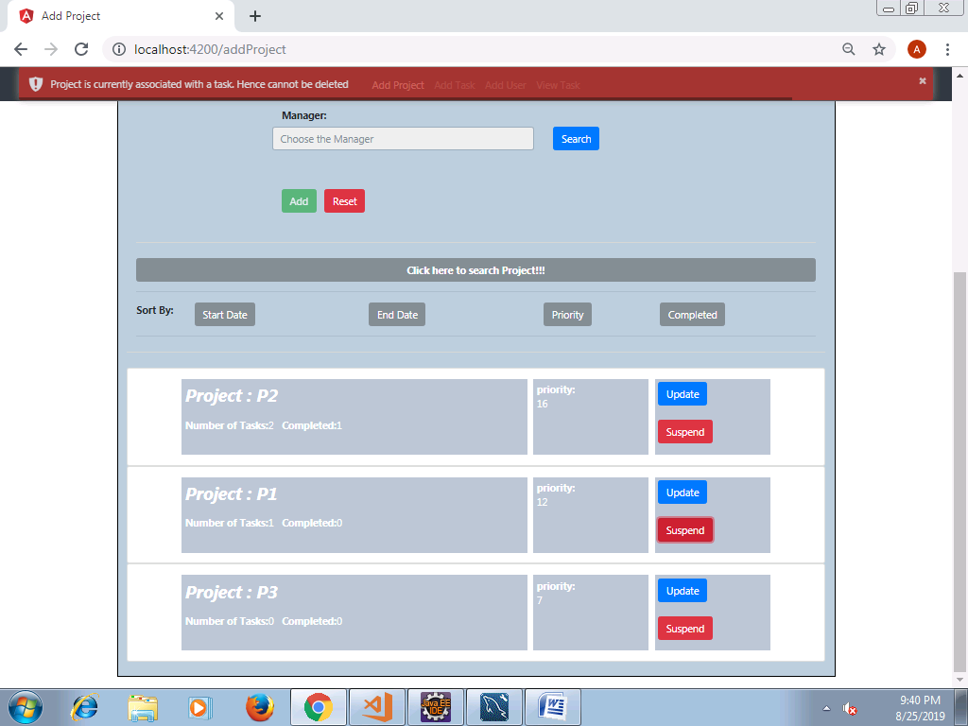

* Project suspended as its not associated with a task.

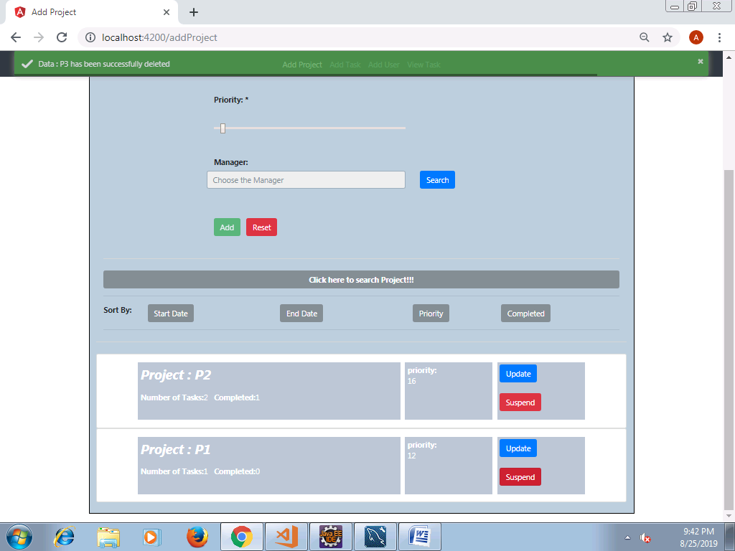

* Also, the projects can be searched adding suitable search filters by using search project option.

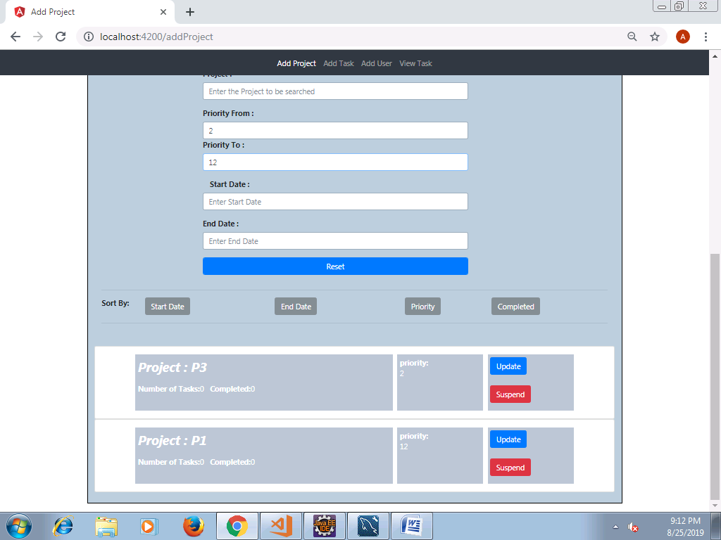

## 4. Adding Task Details

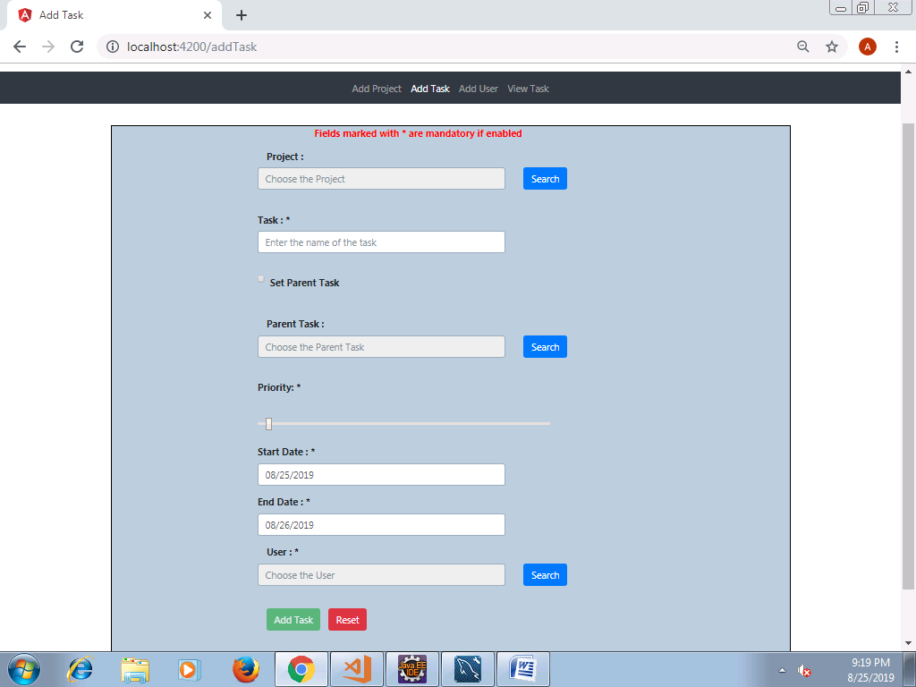

* User can click on Search under Project section to select a project from project list.

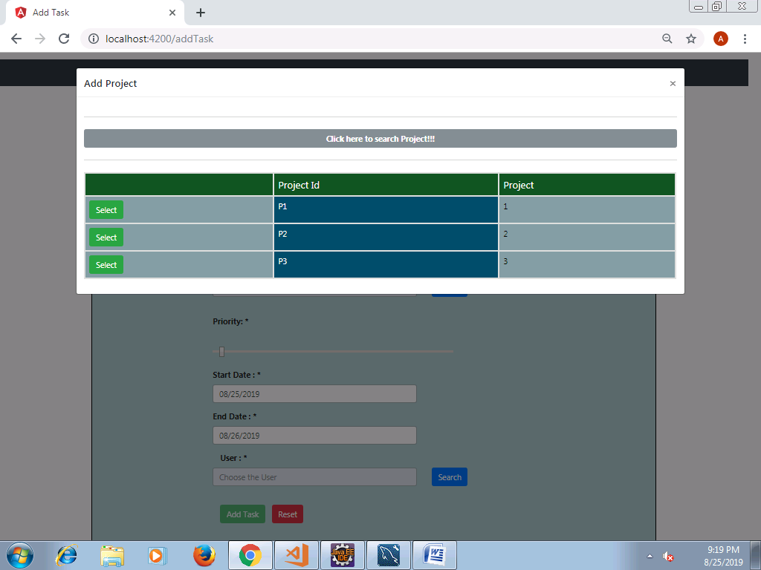

* If the user intends to set the current task as Parent task, check the Set Parent Task. Add Task button will be enabled freezing all other options to edit below.

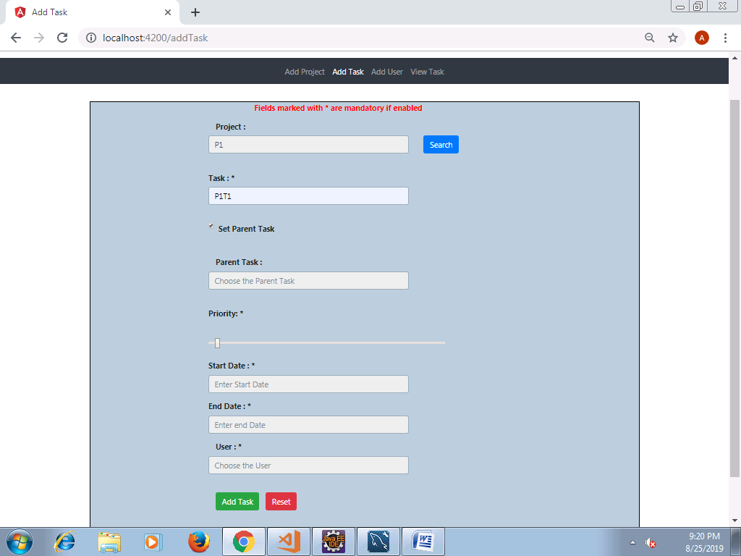

* Otherwise, the user can enter other mandatory fields to add Tasks. On clicking on Add Task, the task gets added successfully, also a popup shows up saying the task registration is successful.

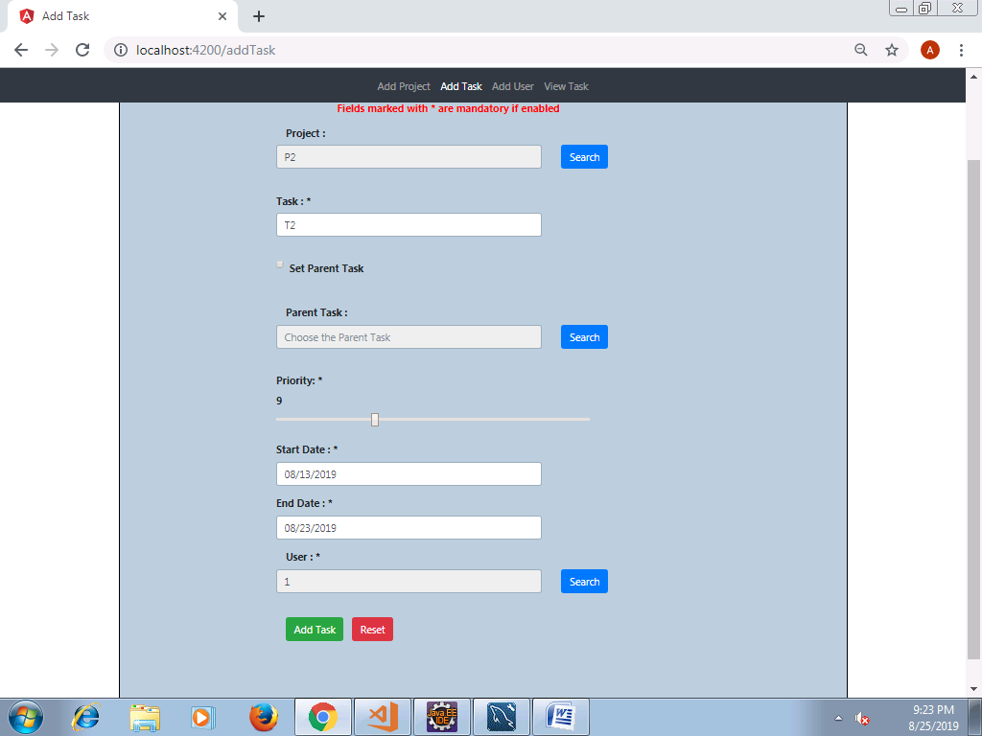

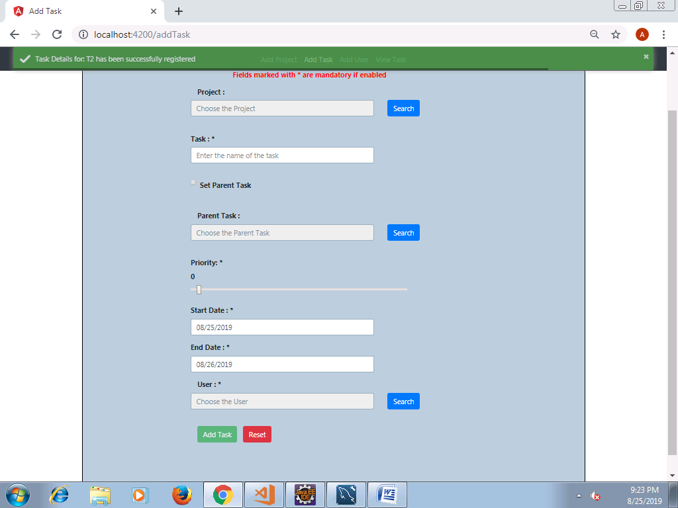

* Appropriate basic field validations are also handled.
* If a parent task is registered, and if the Search button across Parent Task label is selected the parent task from the list can be selected to set Parent Task for the new task that is being added.

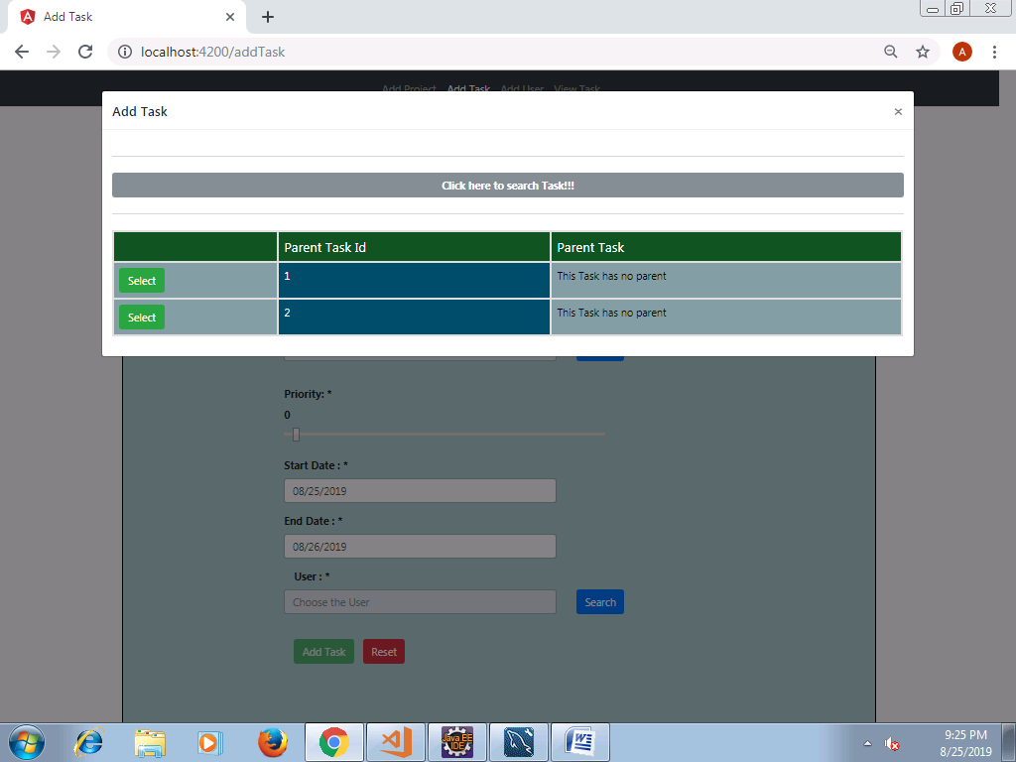

* The Search button across User Label is available when the current task is not a parent task. On clicking, a list of users added will be available, to whom the task will be/should be assigned.

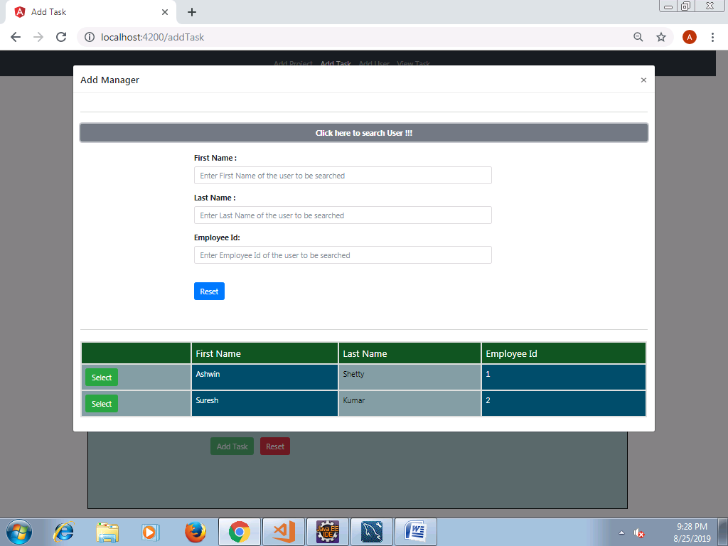

## 5. Viewing the Task Details

* All the tasks that were added will be available in View Task tab.

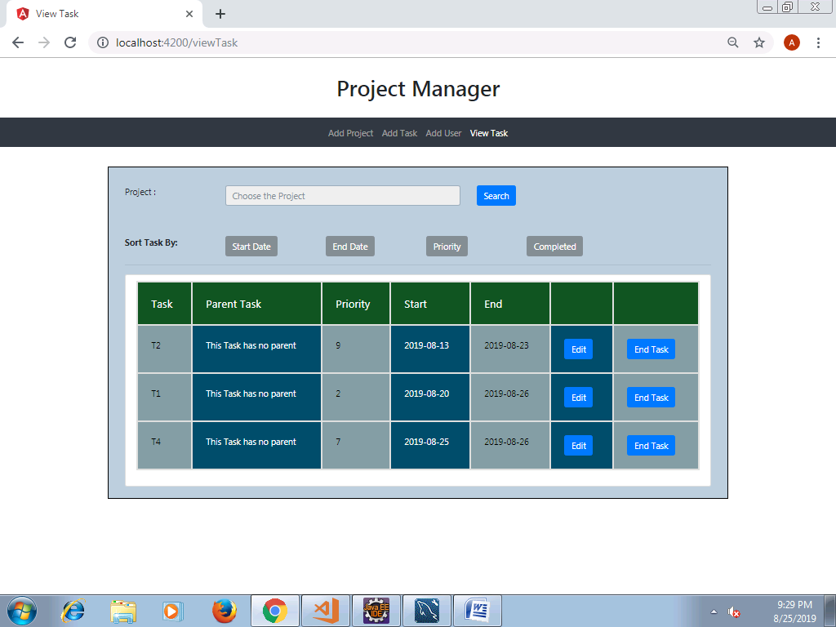

* The user can search for a project by clicking on Search option next to the project. Based on the project selected, list appropriate task list will be filtered out.

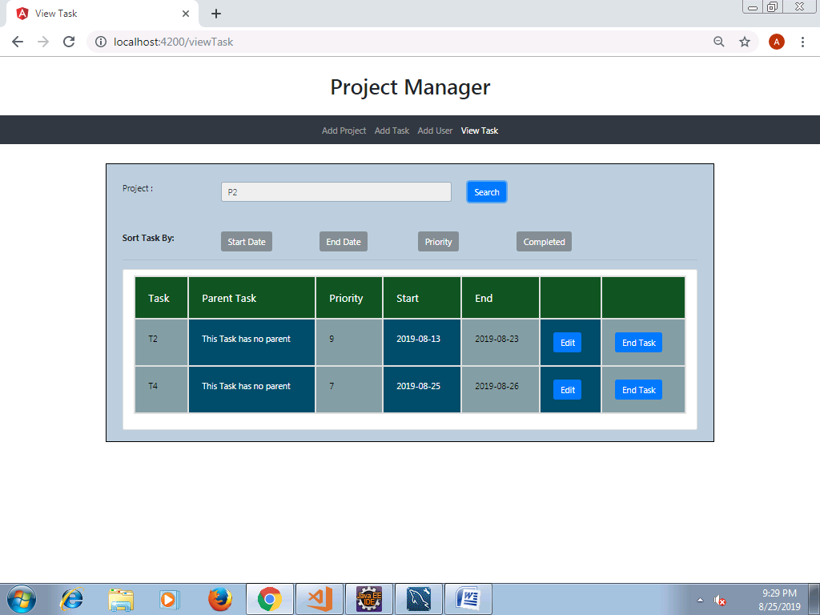

* User can suspend a Task on completion.

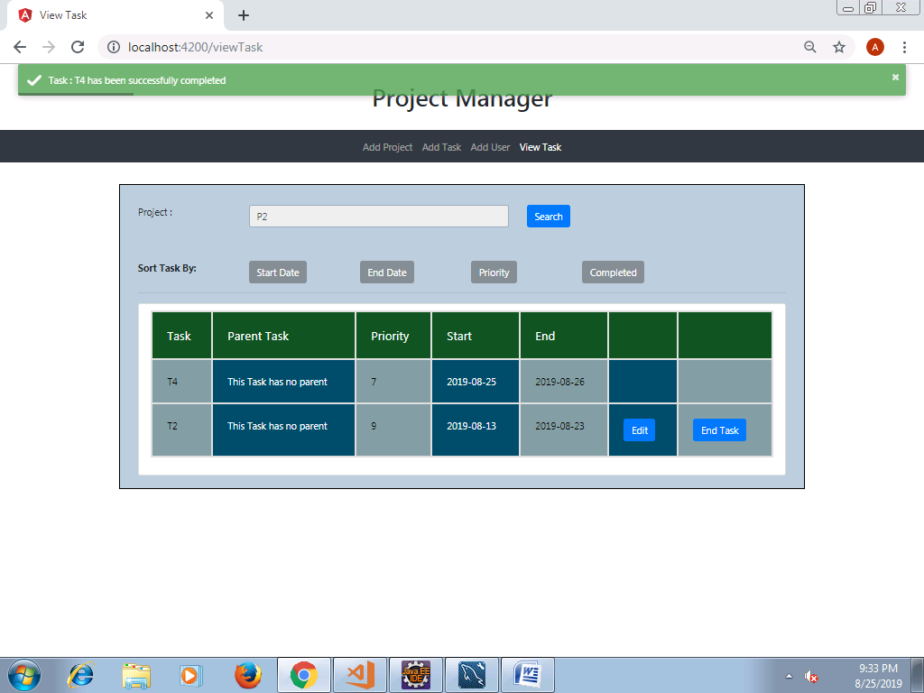

* Task details can be edited. On clicking Edit, the task info can be edited. Once edited, click on Update; On successful update, a popup shows up saying the update is successful.

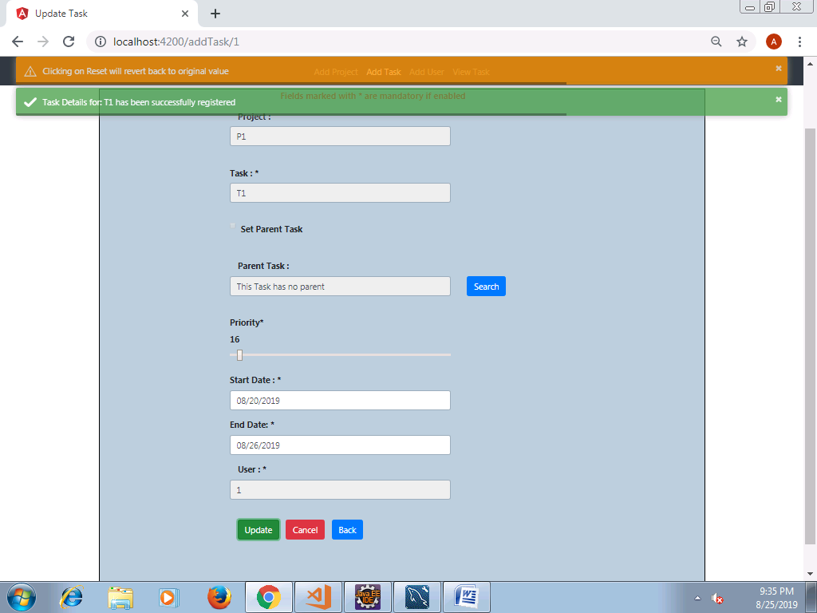

* The Tasks can be sorted based on the Start Date, End Date, Priority, Completed. Below are examples for same in the given order.

